4% = A tiny f………………………..

24% = Almost a q…………………………….

25% = E…………………. a quarter.

26% = R………………………. one quarter.

32% Nearly one-t………………..,

49% = A…………………….. a half, just under a half.

50% Exactly a half.

51% = Just o……………………….. a half.

73% = N…………………………… three quarters.

77% = A………………………. three quarter, more than three-quarter.

79% = Well over three quarter.

**Proportions:**

2% = A t………………………….. portion, a very small proportion.

4% = An i………………………………. minority,

16% = A small m……………………….., a small portion.

70% = A c………………………….. proportion.

89% = A s……………………….. proportion.

Words/ Phrases of Approximation - Vocabulary:

**»**Approximately  
**»**Nearly  
**»**Roughly  
**»**Almost  
**»**About  
**»**Around  
**»**More or less  
**»**Just over  
**»**Just under  
**»**Just around  
**»**Just about  
**»**Just below  
**»**A little more than  
**»**A little less than.

**arrive at , constitute, amounts, account, percentage**

Undergraduates ……………………………..a significant proportion of our freshmen

Managers …………………………for tiny percentage of all employees in our company

The number of qualified workers ……………………..60%

The highest ……………………………..is represented by blue collar workers

Figure ………………………..45% in 2001

***Use these examples as models for your own sentences:***

In 1999, 35% of British people went abroad for their holidays, **while** only 28% of Australians spent their holidays in a different country. The figure for the USA **stood** at 31%.

Around 40% of women in the UK had an undergraduate qualification in 1999, **compared to** 37% of men. The figures for the year 2000 rose slightly to 42% and 38% **respectively**.

The following pie-chart shows the percentage distribution of the expenditure incurred in publishing a book. Write a report based on that data using phrases from the top

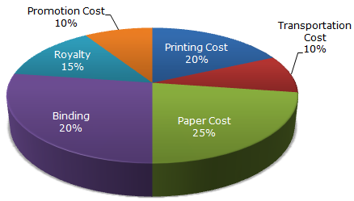

The following graph presents project cost breakdown. Write report summarizing portrayed hereinbelow

